# Social Network Analysis – Assignment (3)

**Number of Edges** removed = 79  
[0, 1, 2, 3, 4, 5, 6, 7, 8, 9, 10, 11, 12, 13, 14, 15, 16, 17, 18, 19, 20, 21, 22, 23, 24, 25, 26, 27, 28, 29, 30, 31, 32, 33, 34, 35, 36, 37, 38, 39, 40, 41, 42, 43, 44, 45, 46, 47, 48, 49, 50, 51, 52, 53, 54, 55, 56, 57, 58, 59, 60, 61, 62, 63, 64, 65, 66, 67, 68, 69, 70, 71, 72, 73, 74, 75, 76, 77, 78]

**Modularity** at each iteration

[0.4231693638839931, 0.426651873767258, 0.4262944847360433, 0.42931959833794997, 0.432, 0.43220416362308256, 0.4329611559392009, 0.4330632716049381, 0.43245387819877024, 0.43198979591836706, 0.43157950010502005, 0.43122837370242206, 0.43144352862552904, 0.43101469237832846, 0.4308284023668637, 0.4306640625, 0.4336104812295286, 0.43750000000000033, 0.44161515721580197, 0.44430555555555534, 0.4443407066934786, 0.4444857312722949, 0.4442905509387502, 0.4460299744897962, 0.4482644628099174, 0.4487311385459531, 0.4525631897472412, 0.45460428994082835, 0.45684352172241427, 0.4603000000000001, 0.45980841316118276, 0.4608289930555554, 0.4606156631960163, 0.45994801512287325, 0.46172839506172836, 0.46229338842975204, 0.4616008653326123, 0.46102607709750565, 0.45984533016061874, 0.4671875, 0.46975673898750814, 0.4698753462603877, 0.4695032870708547, 0.4766589506172839, 0.476530612244898, 0.47902249134948094, 0.4802571166207529, 0.48046875, 0.4810093652445369, 0.48222222222222216, 0.48156956004756246, 0.4802295918367347, 0.4804526748971194, 0.47892011834319526, 0.4792, 0.4791666666666666, 0.47967863894139884, 0.48088842975206614, 0.47959183673469385, 0.47875000000000006, 0.4792243767313019, 0.4791666666666667, 0.47750865051903113, 0.4755859375, 0.4766666666666667, 0.47321428571428575, 0.4689349112426036, 0.4635416666666667, 0.4566115702479339, 0.44749999999999995, 0.43518518518518523, 0.4375, 0.45918367346938777, 0.47222222222222227, 0.5, 0.5, 0.5, 0.5, 0.5]

**Plot of Modularity vs Number of Iterations**

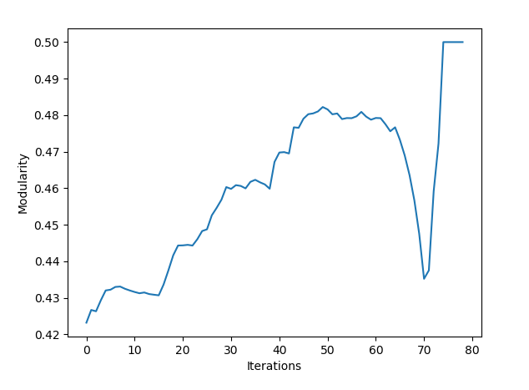

**Community Structure with Highest Modularity**

